Giovanni Martinez

MSDS 460

Jan-14-2024

**Introduction**

The U.S. Food and Drug Administration has established a set of recommended dietary allowances encompassing various nutrients and calorie guidelines. This paper aims to formulate an optimized weekly meal plan comprising five distinct meals. The primary objective is to minimize costs while ensuring that the nutritional requirements outlined by the FDA are met effectively.

**Methods**

The initial phase involves compiling a list of my typical weekly food items. To streamline this process, I opted for five easily preparable meals, each consisting of minimal ingredients. The chosen meals include rice with chicken and vegetables, ground beef with pasta, cereal with milk, a protein meal bar, and eggs with pancakes.

Subsequently, I proceeded to gather comprehensive nutritional data for the ingredients in each meal. This involved researching each item on the Walmart website, noting its price, and recording the published nutritional information. The values were converted into percentages based on the seven components and daily recommended intake.

The cost per serving was calculated by dividing the item's cost by the number of servings in the package. After aggregating the nutritional information, a table detailing the meals and their respective values was constructed.

**Functions**

The variables in this problem are the servings of the five different meals.

The problem underwent seven iterations to compute the nutritional requirements for each of the seven days.



The initial constraints were related to daily nutritional requirements, which had already been converted into percentages. Consequently, the equations were normalized to 100 on the right-hand side.A screenshot of a computer program

One of the requirements was that each meal must be incorporated at least once during the week, to fulfill this requirement, an if statement was devised. This statement established a condition wherein each meal was set to a minimum of one occurrence per iteration until all five meals were included. Once this condition was met for each meal, it became inactive, ensuring that the requirement was satisfied for the entire week.

In the context of this minimization problem, the objective function is defined as the total cost sum of the meals.



Results

Upon running the code without enforcing the condition that each meal must be included at least once, the optimized solution revealed 7.7 portion servings for Meal C, consisting of cereal and milk. The cost of this meal is 3.23 per day or 22.61 per week.

Once the minimum. conditions were introduced, four of the days yielded the following results.

The remaining three days only included meal C, the total weekly cost was found to be $26.66

**Conclusion**

Meal C, comprising cereal and milk, emerged as the most cost-effective option. This outcome may be attributed to the fact that artificially enriched cereal provides a significant quantity of essential nutrients, while the addition of milk contributes essential protein and calcium.

To better represent typical daily meal intake, the problem necessitates additional conditions. This is essential because cereal is not typically consumed as the sole food throughout the week. Proposed conditions include setting limits on maximum servings and maximum meals per meal type (e.g., breakfast-like food or lunch/dinner).

**Appendix**

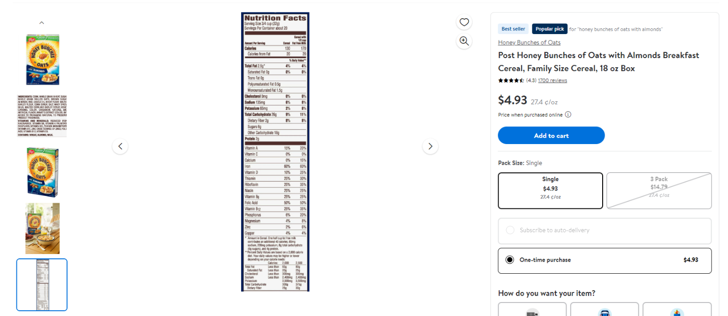

Figure 1

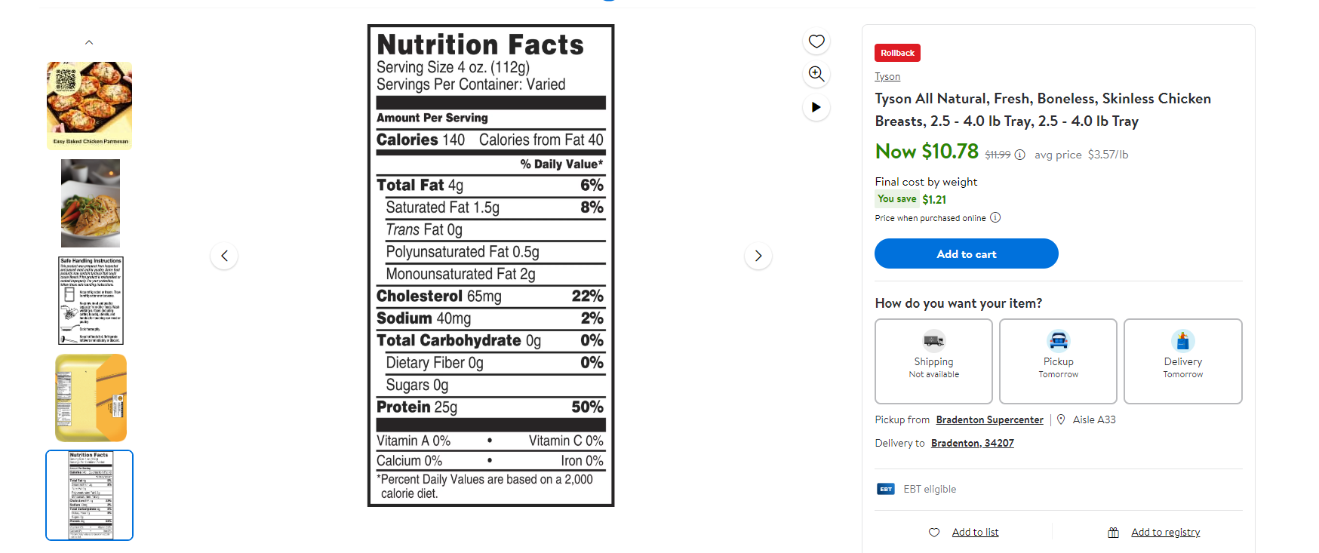

Figure 2

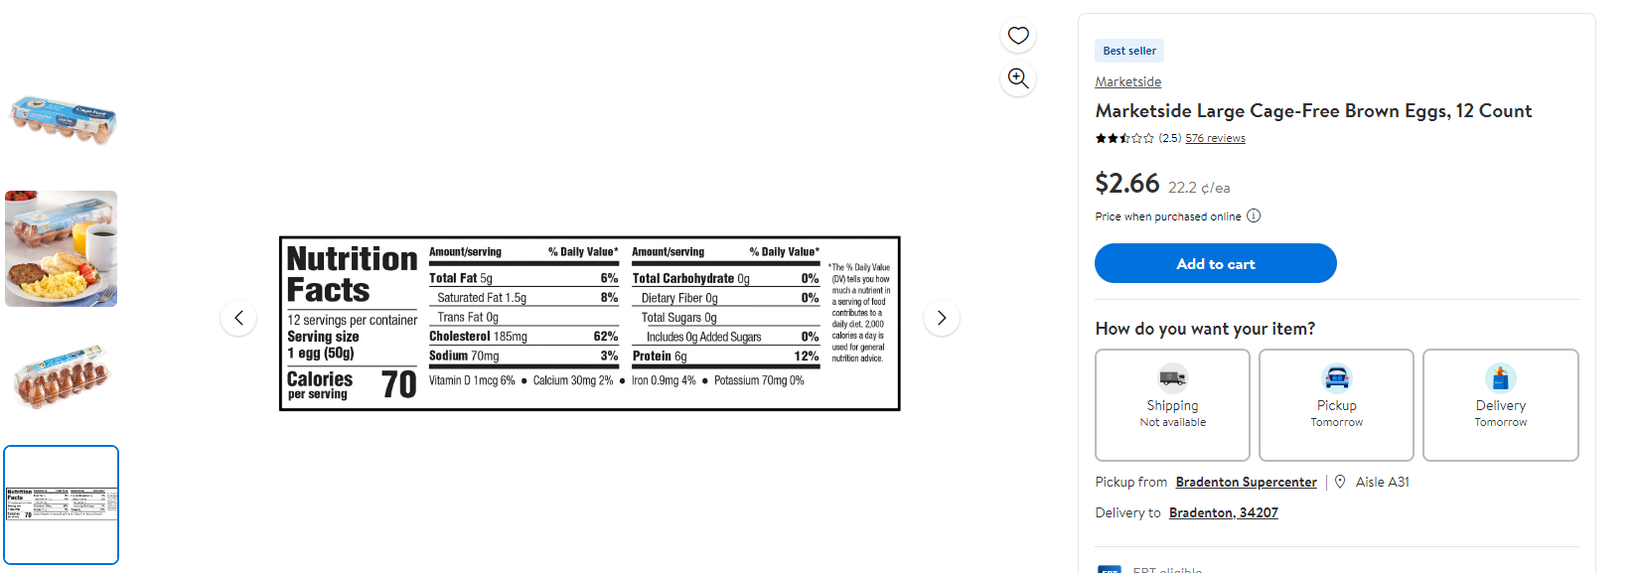

Figure 3

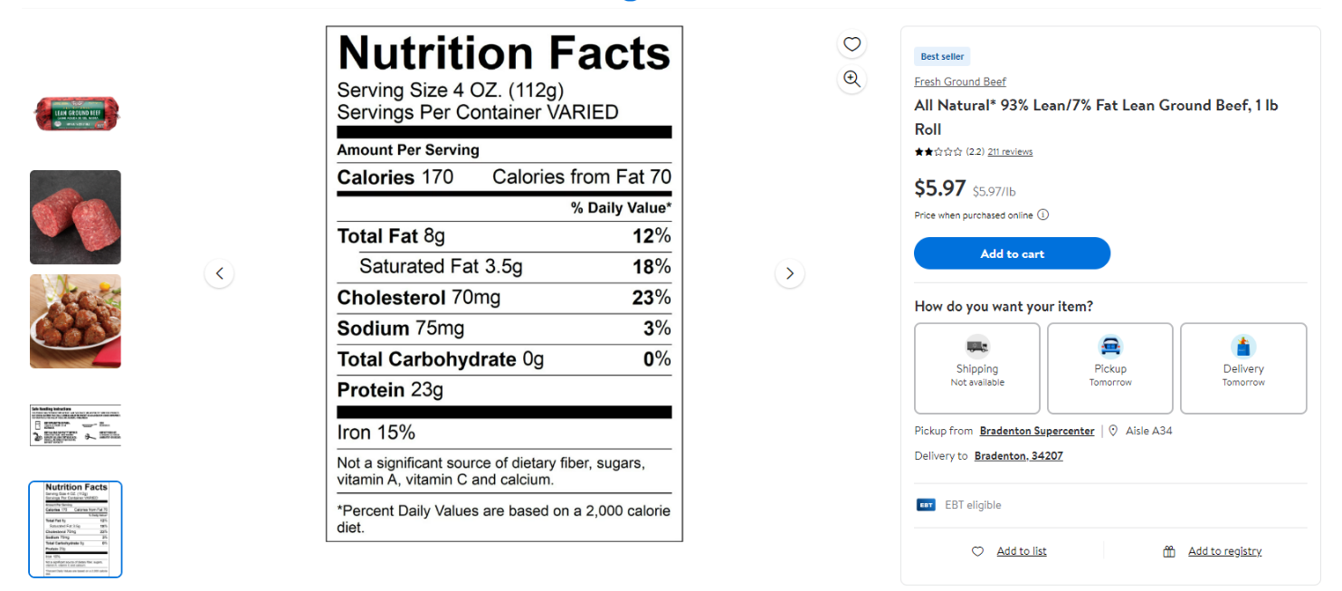

Figure 4

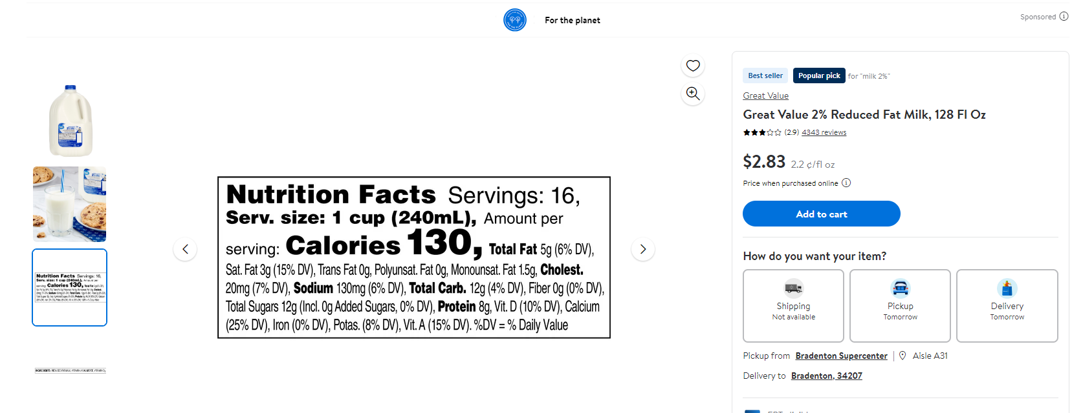

Figure 5

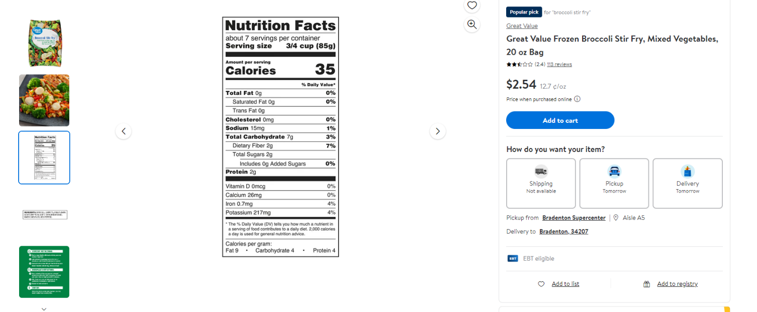

Figure 6

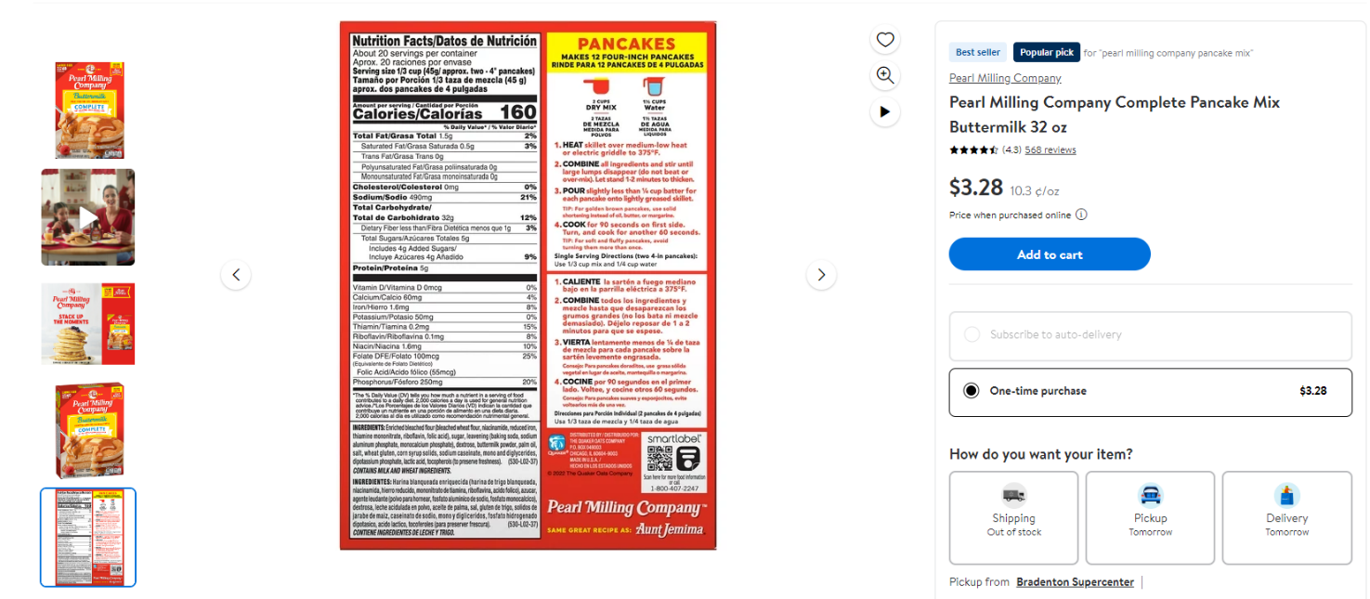

Figure 7

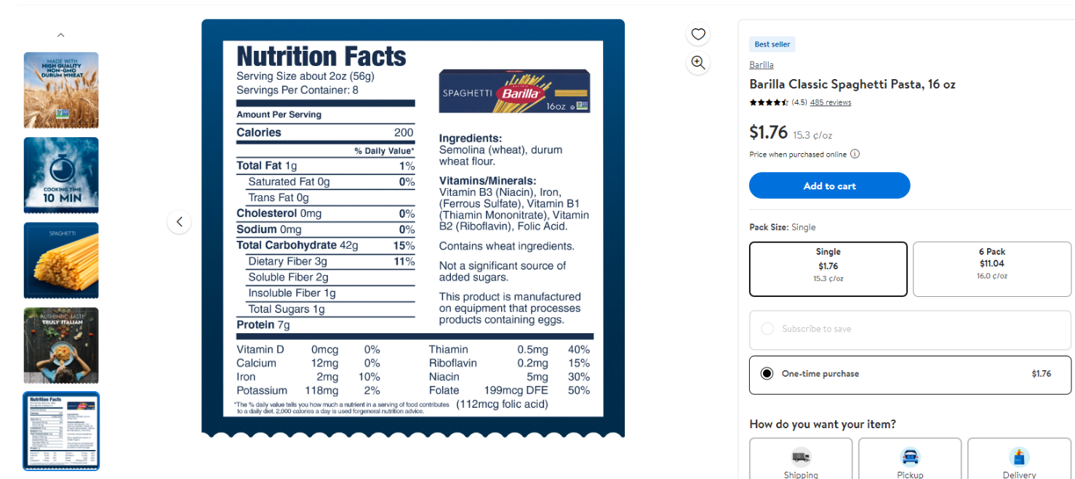

Figure 8

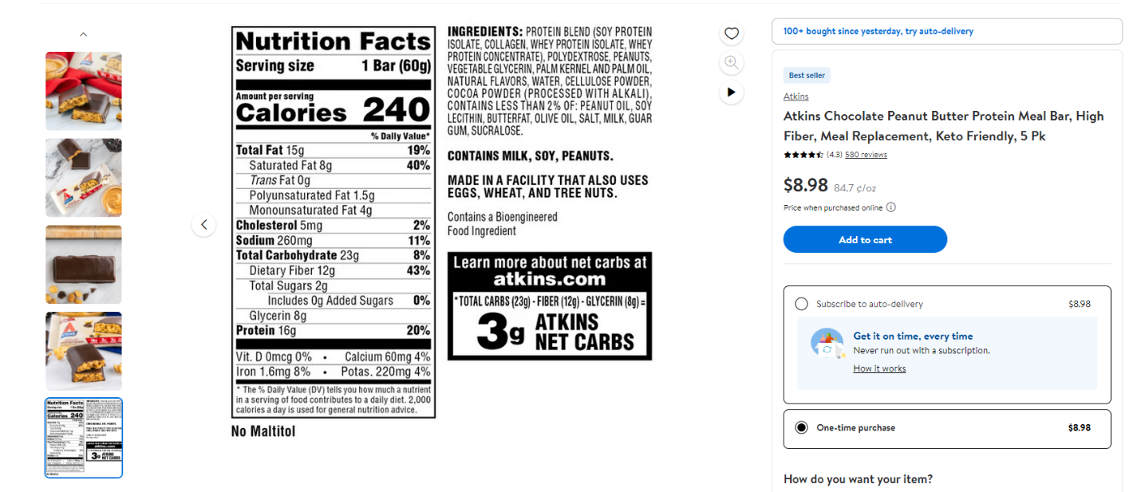

Figure 9

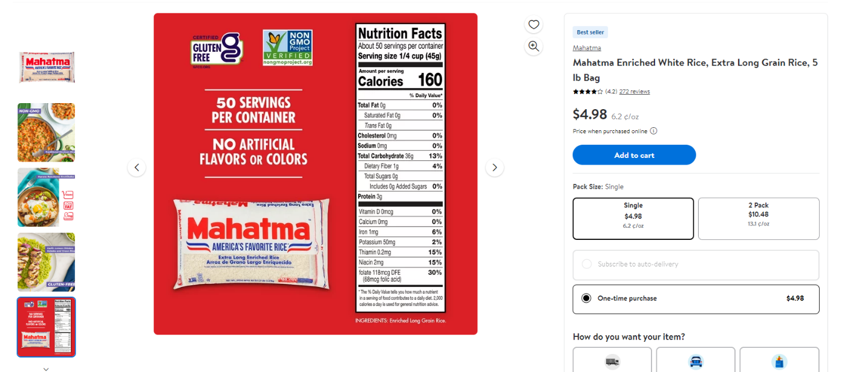

Figure 10